**Agile and Agile Meetings**

Agile stands for being quick and well-coordinated in movement. Unlike traditional meetings, agile meetings are more inclined towards being efficient, time-focused, and goal-driven. Each Agile meeting has a specific goal, ensuring your team knows exactly what to do next and who’s responsible. It’s about providing clear directions and achieving goals efficiently without unnecessary detours.

Agile teams work in short bursts, regularly reviewing and adjusting their approach. These meetings focus on delivering value and sticking to strict time limits, making them more productive than regular meetings.

**Who Should Attend Agile Meetings?**

To ensure a productive agile meeting, only invite the members who need to be there. It is unnecessary to include individuals who have no significant contributions or are not in need of updates on the status of the project.

**Five key Agile Scrum meetings**

If we are using Scrum, the course of each sprint, your team should hold five types of Agile Scrum meetings. Most only occur once per sprint.

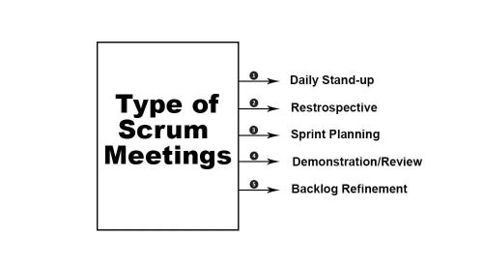

**Sprint planning meeting**

Before your team begins a Scrum sprint, you need to know where you’re going. This is where the sprint planning meeting comes in. A sprint planning meeting should be one of the longest Scrum meetings you hold—plan on two hours of planning for each week of your sprint. (A two-week sprint, for example, requires roughly a four-hour planning meeting.) While this may seem like a lot, remember that you only need to hold one sprint planning meeting per sprint—right at the start.

The purpose of a sprint planning meeting is simple: Establish what you and your Scrum team want to accomplish this sprint and evaluate the bandwidth you have available. From there, you can plan the sprint, assign tasks, and set deadlines. Make sure each team member understands the ins and outs of the tasks they are assigned. You’ll want to invite the product owner to this meeting so they can clear up any ambiguities and help establish expectations.

**Daily standup meeting**

As the most frequently held Agile Scrum meetings, daily standup meetings are the bread and butter of Scrum sprints. They’re short, to the point, and, as the name suggests, held each day—they’re typically the first meeting of the workday. By the end of a standup meeting, each team member should have answered two questions: What did I accomplish yesterday? And what am I going to accomplish today? Standup meetings are also a time for team members to bring up any roadblocks they are facing.

Though daily standup meetings only take between fifteen and thirty minutes, they are an effective way to keep each team member up-to-speed, on task, and openly communicating with others. Because they are held so frequently, standup meetings also allow teams to address problems as they arise, keeping the sprint moving on schedule.

**Sprint review meeting**

Sprint review meetings are held at the end of each sprint. This meeting is an opportunity for you and your team to demonstrate what you’ve accomplished to the product owner and other stakeholders outside of your team.

Your goal in a sprint review meeting is to gather feedback. As you demonstrate new product features and functionality, allow the product owner and other stakeholders to respond to and evaluate your work. Agile methodology relies on open and frequent conversations: As you and your team document, respond to, and act on feedback, remember that these conversations help create a better product.

Certain feedback points may require additional work on the product—add them to your backlog and consider including them in the next sprint. This is a matter of priority: While you should implement the feedback eventually, if other tasks are more pressing you can save it for a sprint down the road.

**Sprint retrospective meeting**

Just like review meetings, a sprint retrospective meeting is held at the end of each sprint. Whereas review meetings include the product owner and other stakeholders, retrospective meetings are primarily for the benefit of your Scrum team—there’s usually no need to get outside players involved.

During a sprint retrospective meeting, address these questions with your Scrum team: What went right this sprint? What went wrong? And what could we do differently next time?

These meetings don’t have to be long (usually somewhere between one and two hours), but they allow teams to constantly improve.

**Product backlog refinement**

Product backlog refinement meetings occur between sprints (usually just once per interim, but you could always schedule another if needed). If you’re anything like us, your backlog tasks are likely a bit rough around the edges. And that’s ok! This meeting is your chance to add clarifying details, establish deliverables, and prioritize the tasks in your backlog.

A thorough product backlog refinement meeting makes your life easier. Remember the oh so long sprint planning meeting you held at the beginning of the sprint? If you take the time to refine your backlog, sprint planning is a quicker and smoother process.